Grade 7 Accelerated · Unit 4 · Lesson 4  Real-World Problems and Significant Digits  Question Bank - Additional 4.04 ANSWER KEY | Name  Date  Period

Show your work. Circle your final answer.
For questions 1 through 4, give the number of significant digits in each measurement.
1. 9,304 kilograms
4
The zero sits between two nonzero digits.

2. 0.00062 metres
2
Leading zeros are never significant.

3. 1.500 seconds
4
The trailing zeros count because a decimal point is written.

4. 430,000 litres
2
No decimal point, so the trailing zeros only hold places.

For questions 5 through 8, solve. Report each answer with the correct precision.
5. A rectangular field measures 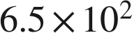 m by 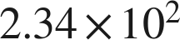 m. Find its area.
 square metres
152,100 exactly; the answer keeps 2 significant digits.

6. A train travels 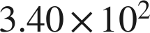 km in 4.0 hours. Find its average speed.
 km/h
340 ÷ 4.0 = 85 exactly; the answer keeps 2 significant digits.

7. Two lengths are measured: 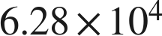 mm and 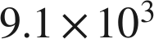 mm. Find their sum.
 mm
62,800 stops at the hundreds place and 9,100 stops at the hundreds place, so the sum, 71,900, stops there too.

8. Two masses are measured: 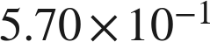 g and 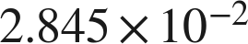 g. Find their difference.
 g
0.54155 exactly; 0.570 stops at the thousandths place, so the answer stops there.

Real quantities.
9. A wind turbine generates about 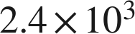 kilowatt-hours of electricity each hour.
a. How much does it generate in 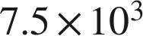 hours? Report the answer with the correct number of significant digits.
 kilowatt-hours
 exactly; both measurements carry two significant digits.
b. A second turbine generates about 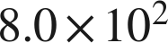 kilowatt-hours each hour. How many times larger is the first turbine's rate? Report the answer with the correct number of significant digits.
3.0 times larger
Exactly 3; two significant digits are justified, so it is written 3.0.

10. A sensor records about 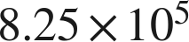 readings each second.
a. How many readings does it record in one minute? Report the answer with the correct number of significant digits.
 readings
exactly. Sixty is a count, not a measurement, so the three digits survive.
b. Four of these sensors run for 30 minutes. How many readings do they record altogether? Report the answer with the correct number of significant digits.
 readings
exactly. Four and thirty are counts.

Reading someone else's work.
11. Bianca adds two measured lengths, 86.4 cm and 0.271 cm. She says that because 86.4 has three significant digits and 0.271 has three, the sum has three: 86.7 cm. Is she right? Explain, and give the correct sum.
She is not right, even though her answer happens to be close. The rule for a sum is about places, not counts: 86.4 stops at the tenths and 0.271 stops at the thousandths, so the sum stops at the tenths. , which becomes 86.7 cm.
Here the two rules give the same answer, which is exactly why the wrong rule survives so long. Ask what she would have written for 1,234 + 5.6.

12. A rectangle's sides are measured as  cm and 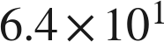 cm. Which is the area, in scientific notation with the correct number of significant digits?
○ A. 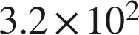 cm²
○ B. 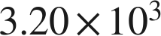 cm²
○ C. 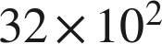 cm²
● D.  cm²
D

